2.54 cm

**AI-Powered Tutoring for Conceptual Clarity in Energy and Momentum among Malaysian Matriculation Physics Students**

Shafiq Bin Rasulan 1

*1 Kolej Matrikulasi Sarawak*

*E-mel ketua penyelidik*

**ABSTRAK**

*Patah perkataan tidak melebihi 200 patah; format italic bersaiz 12; dan justified*. *Jika kertas kajian ditulis dalam Bahasa Melayu, maka abstrak hendaklah ditulis dalam Bahasa Melayu. Jika kertas kajian ditulis dalam Bahasa Inggeris, maka abstrak hendaklah ditulis dalam Bahasa Inggeris*

*Kata Kunci : Tiga hingga lima patah perkataan*

# **INTRODUCTION**

Latar belakang, pengalaman PdP, tujuan/ kepentingan, andaian, nilai dan kepercayaan pengkaji terhadap PdP dan lain-lain berkaitan

* 1. Latar Belakang

# **2.0 REFLECTION ON PAST TEACHING PRACTICES**

Over the past few semesters teaching Physics at the Malaysian Matriculation level, I have observed a recurring pattern of conceptual confusion among students, particularly in the topics of energy and momentum. Despite covering the syllabus thoroughly using standard lecture-based approaches and problem-solving tutorials, many students continued to display fundamental misconceptions. For instance, some believed that heavier objects always have more momentum regardless of velocity, while others misinterpreted energy as something that gets "used up" during a process, indicating a disconnect between instruction and conceptual internalisation.

One strategy I implemented in response was the use of formative assessments such as quizzes and short written explanations, designed to reveal students' thinking. While these activities provided insight into students’ misunderstandings, the challenge was responding effectively and promptly to each student's needs in a large class setting. The lack of immediate, individualized feedback limited my ability to engage students in meaningful conceptual dialogue — a key factor in promoting sensemaking and conceptual change (Author, Year).

I also encouraged peer discussions and group problem-solving, which helped to some extent. However, the discussions often reinforced superficial reasoning when misconceptions went unchallenged. The limitations in student responsiveness and the constraints of face-to-face class time highlighted the need for a more adaptive and scalable support system — one that could respond to each student's reasoning in real time (Author, Year).

Initial data gathered from diagnostic assessments — particularly items adapted from the Energy and Momentum Conceptual Survey (EMCS) — confirmed that a significant proportion of students held incorrect or incomplete mental models. In a pre-intervention diagnostic test administered to 40 students, only 35% correctly answered items related to momentum conservation in inelastic collisions, and less than 30% correctly explained energy transformation in closed systems. Additionally, qualitative responses from reflective journals showed that students struggled to relate the equations to real-world phenomena.

These reflections underscored the need to integrate tools that can offer immediate, dialogic feedback tailored to each learner’s thought process. AI tools such as ChatGPT and Gemini present an opportunity to fill this pedagogical gap by providing Socratic-style tutoring, encouraging self-explanation, and sustaining cognitive engagement beyond classroom hours (Author, Year). The integration of such tools, therefore, emerged not as a replacement for teaching, but as a necessary extension of it — to enhance conceptual understanding and support responsive teaching at scale.

Teaching physics at the Malaysian Matriculation level has consistently revealed a tension between curriculum coverage and deep conceptual understanding. Despite completing syllabus content on time and employing structured tutorials, I observed that many students were still unable to grasp the underlying principles of energy and momentum. These issues persisted even among students who could solve numerical problems mechanically. This indicated a disconnect between algorithmic proficiency and conceptual understanding — a common phenomenon in physics education (Author, Year).

Formative assessments, such as exit tickets and conceptual quizzes, were used regularly to identify misconceptions. In one quiz focused on inelastic collisions, 65% of students incorrectly stated that kinetic energy is conserved during the collision. When asked to explain energy transfer in a pendulum system, 70% of students gave responses that suggested energy is “used up” at the highest point, rather than transformed between kinetic and potential forms. These formative results signaled the prevalence of naive conceptions among learners.

In addition to quantitative data, student reflections collected via journals and anonymous surveys revealed key insights. Several students expressed uncertainty or discomfort when faced with conceptual questions:

*“I memorized the formulas, but when the question asked ‘why’ something happens, I didn’t know how to explain it.”*

*“Sometimes I think I understand, but when I try to explain it, I get confused again.”*

*“Discussions help me sometimes, but I’m afraid of giving wrong answers in class.”*

These reflections highlight two interrelated problems: students’ difficulty articulating their thinking, and the lack of a low-stakes, responsive platform for conceptual exploration. Although I incorporated peer discussions into the lessons, these were not always effective at addressing misconceptions. In many cases, incorrect ideas were reinforced when peers were equally uncertain. My own attempts to offer feedback during class were constrained by time, resulting in missed opportunities for targeted conceptual intervention.

The need for an individualized, dialogue-based support system became increasingly clear. AI tools such as ChatGPT and Gemini, which can simulate Socratic questioning and provide feedback based on student input, emerged as potential solutions. Their ability to engage students in real-time, explain complex ideas conversationally, and adjust explanations based on follow-up questions makes them uniquely suited to address the challenges I encountered. These AI tools do not replace the role of the teacher, but they offer a scalable way to extend responsive teaching beyond the classroom and personalize the learning experience (Author, Year).

**Early Diagnostic Data**

Below is an outline of early diagnostic data collected before the intervention, which supports the need for change:

**Table 1.** Pre-test Results

|  |  |  |
| --- | --- | --- |
| **Conceptual Area** | **Correct Response Rate** | **Common Misconceptions** |
|  |  |  |
|  |  |  |
|  |  |  |

These data further confirmed the importance of addressing students' underlying reasoning processes, not just their ability to recall formulas.

# **`3.0 RESEARCH FOCUS/ AREA OF CONCERN**

This study focuses on students’ conceptual difficulties in the topics of energy and momentum within the Malaysian Matriculation Physics curriculum. These two fundamental concepts were selected based on both classroom observations and diagnostic data that consistently pointed to deep-rooted misconceptions. Students frequently misinterpret energy as something that is consumed or depleted, rather than transferred or transformed within a system. Similarly, momentum is often misunderstood, with students conflating it with either force or mass alone, leading to incorrect predictions in collision-related problems. These conceptual gaps hinder students’ ability to reason through physical phenomena and apply principles meaningfully across contexts.

The focus of the study is directly aligned with the learning needs of the students, as highlighted in pre-intervention assessments and personal reflections. Student feedback further supports this emphasis; many learners reported struggling to explain energy conservation in everyday contexts or to differentiate between momentum and inertia. These difficulties are not just isolated to a few individuals but are common across the cohort, making the issue both urgent and significant.

In selecting this focus, three criteria were considered: importance, feasibility, and relevance. The importance of these concepts lies in their foundational role within classical mechanics and their prominence in examinations, making mastery essential for academic progression and scientific literacy. From a feasibility standpoint, the topics align with the current teaching semester and can be seamlessly integrated into the existing instructional timeline. Furthermore, the proposed intervention using AI tools such as ChatGPT and Gemini is practical, as it requires minimal infrastructure and can be accessed by students outside the classroom, allowing for flexible and scalable support. Relevance is also a key factor; the early data and student reflections clearly show that these misconceptions are widespread and persistent. The intervention, therefore, responds directly to real and documented learning difficulties rather than theoretical assumptions.

By narrowing the scope to energy and momentum, this study aims to address both conceptual and pedagogical challenges. It seeks not only to improve students’ understanding of specific content areas but also to explore how AI-based dialogue can serve as a tool for individualized sensemaking in physics education. The targeted nature of the focus ensures that the action taken is meaningful, manageable, and reflective of the students' actual learning experiences.

# **4.0 RESEARCH OBJECTIVES**

The primary objective of this study is to improve students’ conceptual understanding of energy and momentum in the Malaysian Matriculation Physics curriculum through the integration of AI dialogue-based tutoring tools, specifically ChatGPT and Gemini. This objective is grounded in the earlier identification of widespread misconceptions in these topics, as revealed through diagnostic assessments and student feedback.

To achieve this, the study aims to pursue three specific objectives. First, it seeks to measure the extent to which AI-supported dialogue can enhance students’ conceptual understanding, as indicated by improved performance in pre- and post-intervention assessments. Second, it aims to explore how students interact with AI tools during their learning process, focusing on the nature of their questions, explanations, and revisions. Third, it aims to evaluate the practicality and responsiveness of AI tools as supplementary learning aids, particularly in helping students clarify and refine their ideas outside the classroom.

These objectives are realistic and measurable within the scope of the study. Conceptual gains will be evaluated using items adapted from the Energy and Momentum Conceptual Survey (EMCS), while student interactions and reflections will be analysed qualitatively to assess engagement and sensemaking. Collectively, these objectives align closely with the study's central concern: addressing persistent misconceptions by leveraging the unique affordances of AI-based dialogue.

# **5.0 TARGET GROUP**

The target group for this study consists of students enrolled in the Two-Semester System of the Malaysian Matriculation Programme (Program Matrikulasi KPM) at Sarawak Matriculation College for the 2024/2025 academic session. These students are currently taking Physics as one of their core subjects. The selection was based on early diagnostic data that identified persistent misconceptions in energy and momentum, as well as their readiness to engage with new learning tools such as AI-based tutoring systems.

The students chosen for this study obtained at least a grade B in Physics in their SPM examination, indicating a foundational understanding of the subject but with room for conceptual improvement. This selection criterion ensures the group is both relevant to the focus of the study and likely to benefit from the intervention. A total of 30 students were identified from two tutorial groups under my supervision. These students were selected to ensure consistency in teaching delivery and access to AI tools during the research period.

The target group includes both male and female students, with a mix of ethnic backgrounds typical of the Malaysian matriculation context, including Malay, Chinese, Iban, Bidayuh, and other indigenous groups. Academically, these students vary in their overall science performance but share a common challenge in mastering abstract physics concepts, particularly those requiring conceptual reasoning beyond memorisation. Their demographic diversity and varied learning styles make them a suitable and representative group for investigating the effectiveness of AI-supported interventions in improving conceptual understanding.

# **6.0 ACTION IMPLEMENTATION**

The intervention in this study was implemented with the aim of enhancing students’ conceptual understanding of energy and momentum by integrating AI-based tools, specifically ChatGPT and Gemini, into the teaching and learning process. The intervention was guided by the Kemmis and McTaggart Action Research Spiral Model, which emphasizes an iterative cycle of planning, acting, observing, and reflecting. This model was particularly suitable as it provided a structured yet flexible framework that allowed for continuous improvement based on real-time classroom experiences and student feedback.

During the planning phase, diagnostic assessments and student reflections were analysed to identify prevalent misconceptions related to the topics of energy and momentum. Based on this preliminary data, specific lesson activities were designed to incorporate AI dialogue as a strategy to support sensemaking. Students were introduced to the use of ChatGPT and Gemini and were trained to pose effective conceptual questions and evaluate the quality of AI-generated explanations. These preparatory steps ensured that students could engage meaningfully with the tools rather than rely on them for surface-level answers.

The actual teaching and learning activities were implemented over two instructional cycles covering the core concepts of energy and momentum. Lessons were restructured to include targeted AI interactions. For example, students were given conceptual prompts before class, such as “Where does the energy go after a collision?” or “Is momentum always conserved?” and were asked to explore these ideas in conversation with either ChatGPT or Gemini. In class, students engaged in guided discussions where they shared their AI-based findings, compared interpretations, and clarified misunderstandings with the help of peers and the instructor.

Each student was provided with a structured worksheet to guide their AI conversations. These worksheets included concept questions, checkpoints for reflection, and sections for summarising their learning. By documenting their dialogue with the AI, students were able to externalize their thought processes, which supported deeper reflection and gave the teacher insight into their reasoning. These worksheets also ensured alignment with the syllabus and allowed for consistent monitoring of the intervention.

One of the key innovations in this study was the use of AI as a form of responsive teaching assistance. The chatbots were able to provide immediate, tailored feedback to students' queries, helping them to refine their understanding in a non-threatening and conversational manner. Many students reported feeling more confident asking questions to the AI compared to asking their teacher, which contributed to increased engagement and more active participation in class.

The intervention was feasible and required minimal additional resources, as students used their own mobile devices to access the AI platforms. The combination of AI-supported learning, structured guidance, and collaborative classroom discussion created a balanced environment where students could test and reshape their conceptual understanding through dialogue. The entire cycle was repeated twice, with post-cycle reflections and adjustments made to improve clarity, task design, and student support. This reflective, adaptive approach ensured that the intervention remained grounded in student needs and instructional realities.

# **7.0 PEMERHATIAN DAN DAPATAN KAJIAN**

Pengumpulan dan analisis data serta perbincangan dapatan. Format rajah dan jadual seperti berikut:

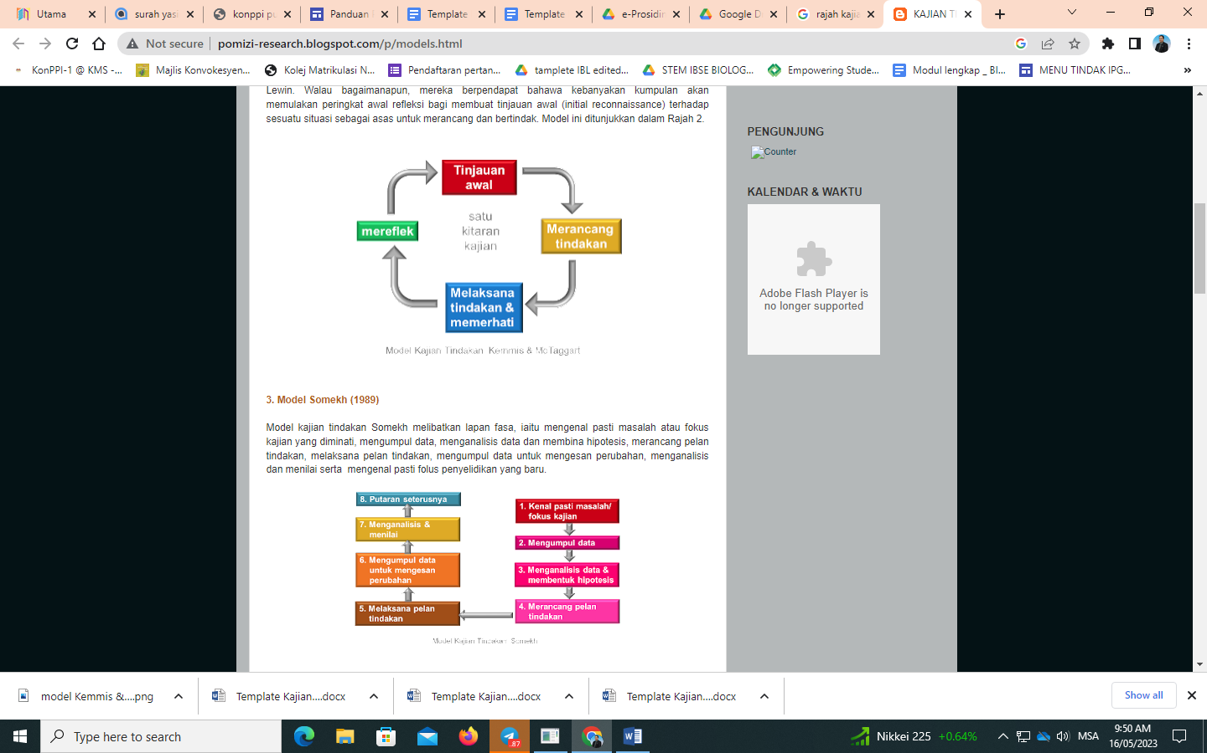

**Rajah 1.** Model Kajian Tindakan Kemmis & Mc Taggart

**Jadual 1.** Perbezaan markah A dengan B

|  |  |  |  |
| --- | --- | --- | --- |
| **Sampel** | **Markah A** | **Markah B** | **Perbezaan** |
|  |  |  |  |
|  |  |  |  |
|  |  |  |  |

# **8.0 REFLEKSI DAN KESIMPULAN**

Penerangan perubahan. Kekuatan dan kelemahan kajian, pencapaian objektif serta keberkesanan tindakan/ aktiviti. Membuat penilaian terhadap intervensi/ kekuatan dan kelemahan kajian, pencapaian objektif dan keberkesanan tindakan/ aktiviti. Cadangan kajian lanjutan.

# **PENGHARGAAN**

# **RUJUKAN**

Mengikut format gaya penulisan APA (*American Physiological Association*) edisi terkini.

# **LAMPIRAN**